Task 1: Process Synchronization and Child Process Monitoring Using waitpid()
Code:
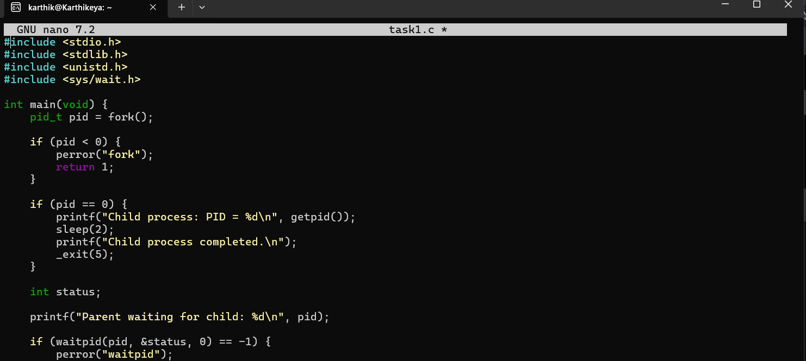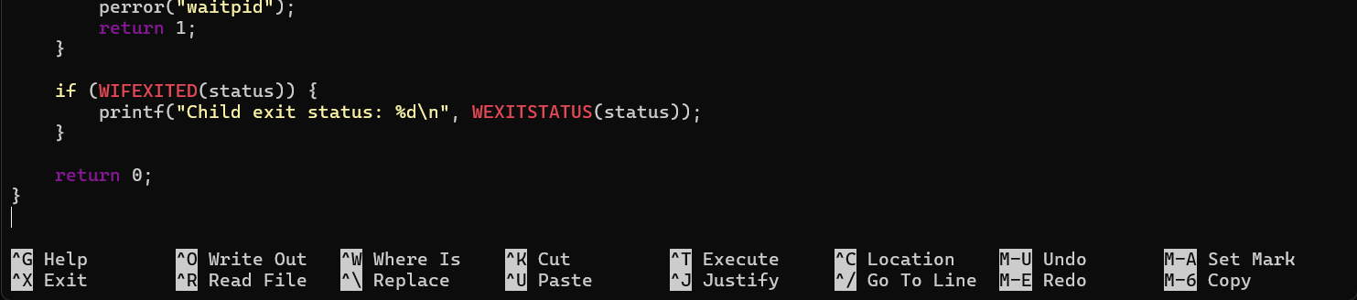

Output:
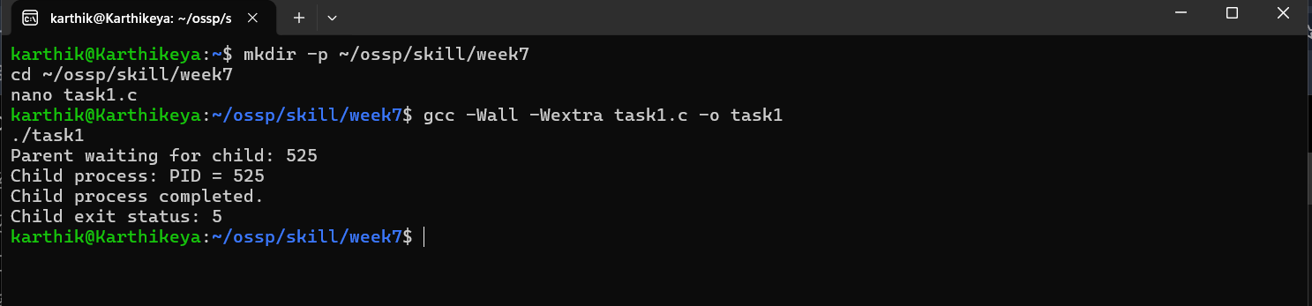

Task 2: To Retrieve PATH Variable, Parse Search Directories, Locate Executables, Verify Permissions, Handle Missing Commands, Test Command Resolution.
Code:
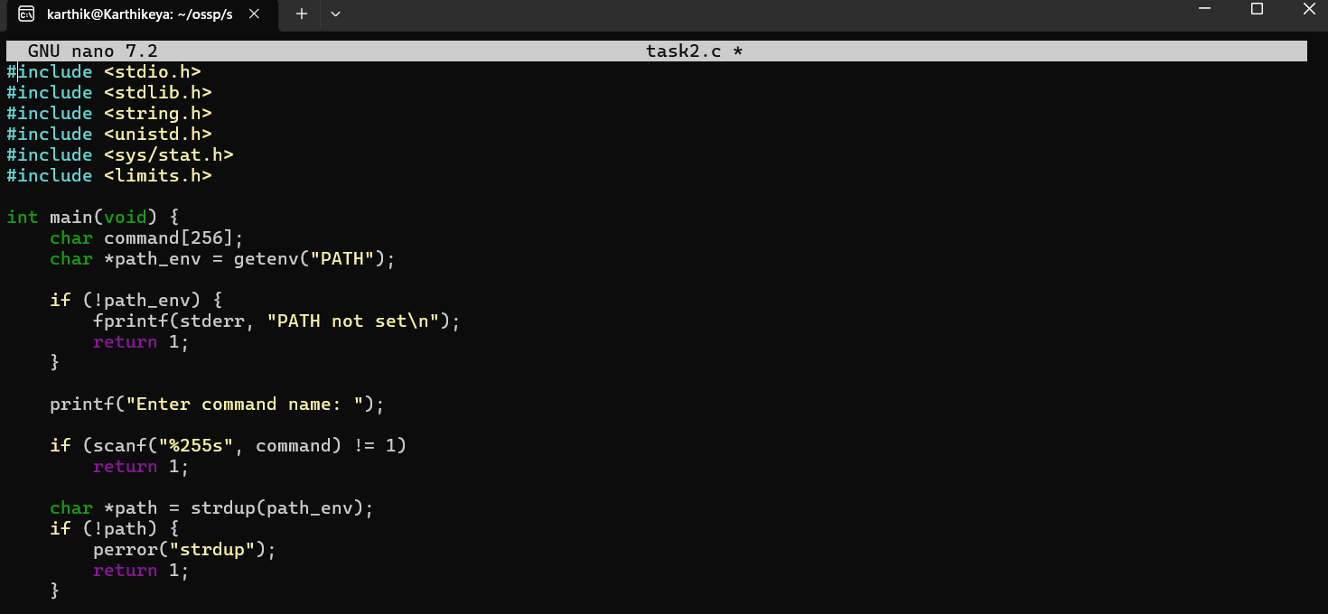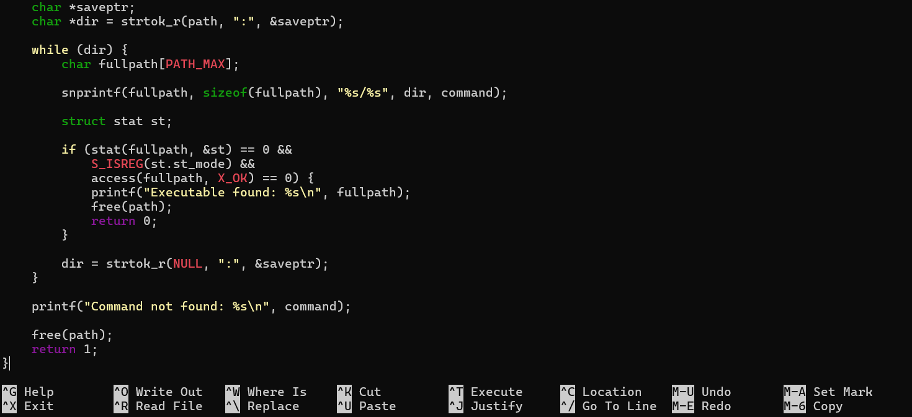

Output:
